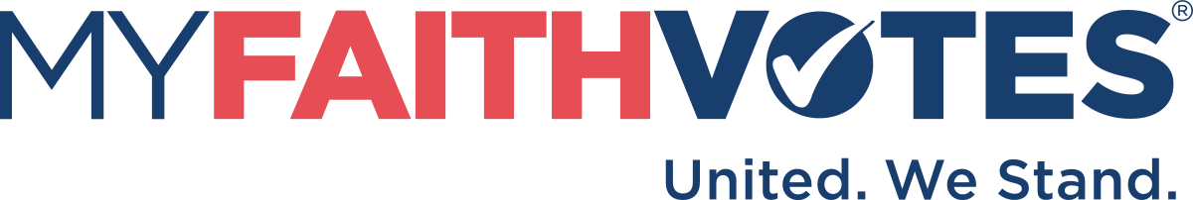

Job Description
Position: Action Partner Administrative Assistant

Purpose
We are seeking an Administrative Assistant to support the National Director of Engagement and the Action Partner Community by providing administrative support, organizational support, communications facilitation, and coordination of scheduling and event planning.

About My Faith Votes
My Faith Votes is a movement of Christians in America who recognize our faith has the power to influence change. We are empowering and equipping believers to stand for biblical values in the public square and vote in every election so that America stands strong for God.
Vision: An America where God is honored in the church and in the public square.
Core Values:
- We believe faith has an essential place in politics and in the public square.
- We believe Christians in America have a moral and biblical obligation to vote.
- We believe in the power of prayer to change culture and government.
- We believe the Bible is truth and we are committed to a biblical worldview.
- We take Jesus and his commands seriously.
- We fear God, and we believe in acting upon what we believe.

Responsibilities
- Manage and maintain the schedule of the Director as needed, including meetings/appointments, travel and conferences.
- Organize, attend, and participate in Action Partner program meetings.
- Document and follow up as required on important actions and decisions from meetings.
- Work with the Director to prepare necessary presentation materials for meetings and conferences.
- Work with the Director to ensure project deadlines are met.
- Ensure all project tasks are appropriately entered and maintained in project management system.
- Undertake project tasks as necessary.
- Execute a variety of project management administrative tasks such as taking and distributing meeting notes with action items, ordering and shipping materials, and maintaining progress reports.
- Assist in the creation and preparation of outward-facing documents and communications to the grassroots Action Partner community.
- Respond to and help solve incoming requests from the grassroots community in a timely, encouraging, and effective manner.
- Organize and maintain files related to the Action Partner community in MS SharePoint and Teams
- Use internal systems CRM and reporting system for preparing weekly/monthly reports and for conducting needed research/analysis
- Maintain list of all activities by the Action Partner Community during the year
- Maintain and facilitate schedule of event kits
- Follow up on Action Partner list maintenance
- Facilitate thank you/encouragement activities for Action Partners
- Provide clerical and general office support, as requested.

Job Qualifications & Requirements
- Is a born again believer of Jesus Christ and maintains faithful fellowship with other believers (Hebrews 10:25); maintains a courteous, Christ-like attitude in dealing with people within and outside of My Faith Votes; exhibits integrity in professional and personal life; upholds MFV’s ministry in prayer; passionate about the mission of the organization.
- Excellent interpersonal skills
- Excellent communication skills, both written and verbal
- Strong attention to detail
- Intuitive problem solver
- Self-motivated and self-directed
- Efficient time management
- Strong proficiency with MS Office suite of products
- B.S. in Management or related field

Reports To
National Director of Engagement

Location
Seeking a candidate in the Raleigh, North Carolina metropolitan area.

